CECS 543 Semester Project Iteration 3 Due Mar 22, Demo in lab

And now the fun starts! Halstead and McCabe on Java!

- Add to the main menu bar "Project Code"
  - Under Project Code add menu items "Add code" and "Project code statistics"
  - Clicking "Add code" opens a file dialog that permits the user to select any number of java source code files to add to the "project"
    - This dialog should be set to select multiple files
    - Optional set it to select only java files
    - OK transfers the files back to MetricsSuite, Cancel cancels.
  - Clicking "Project code statistic" causes each project code file to be parsed for the basic statistics (metrics) required, one file per panel. Each panel is named for the file name it contains.
    - The metrics/statistics/information are
      - See Figure 2
      - They are identical for all files except for McCabe's in that the number of lines of output depend on the number of constructors/methods in the file.
      - These metrics/statistics are for the whole file.
    - The control holding the statistics must scroll.
    - The only "save" required is/are the file name(s).
    - Upon "Opening" a saved project with code, simply reparse the files to reproduce the output
- Optional - for 12% bonus to the project grade
  - Add a panel at the left of the main screen to display a "project tree".
  - The root node is named for the project
  - All leaf nodes (for the tree needs only 2 levels) correspond to the panels of the project, one per panel
  - Each panel must have a unique name. For code files it is assumed that names are unique. The SMI panel since it's a singleton can be named SMI. The FP panel must be given unique names. A message box appears upon creation of a FP panel requesting a name for the panel. The name appears in the tree and on the tab for the panel.
  - To each leaf, add a context-sensitive right click producing popup menu with Open/Close/Delete.
    - for each panel that is open, Close will close it - that is, remove it from the tabbed pane but NOT from the project tree or the project. Selecting Open for an open does nothing .
    - for each panel that is closed, Open will restore the panel to the tabbed pane (with its information intact). Closing a closed panel does nothing.
    - for each leaf node in the tree, Delete removes the panel from the tabbed (if it is open), removes the leaf node from the project tree, and deletes the panel from the project.
    - A message box confirming the deletion of a panel must be displayed.

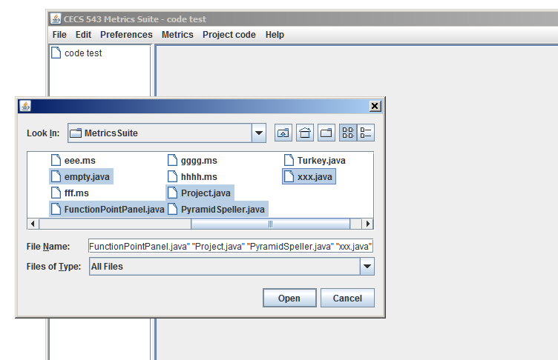
Figure 1Add code dialog

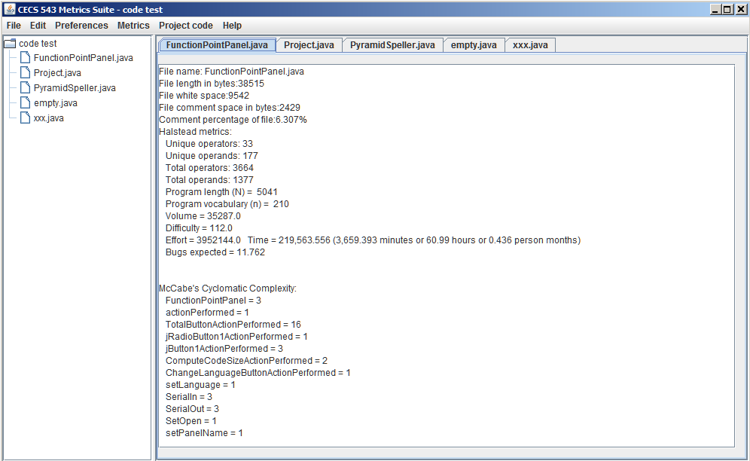
Figure 2 Five code panels added
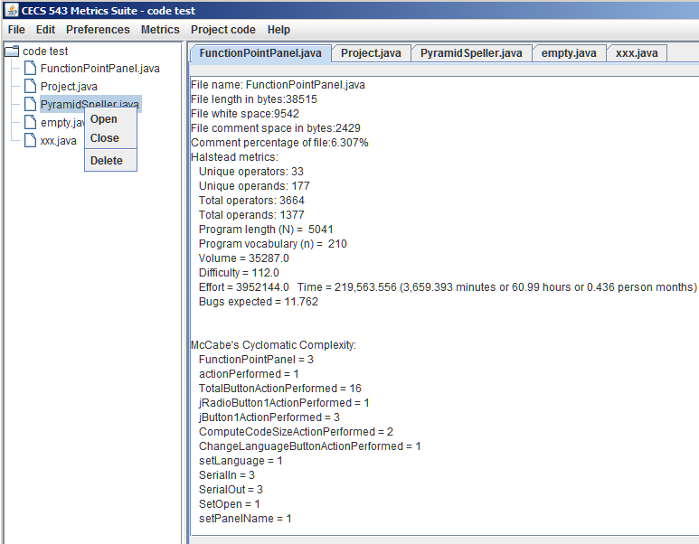
Figure 3 Context sensitive popup menu on leaf nodes

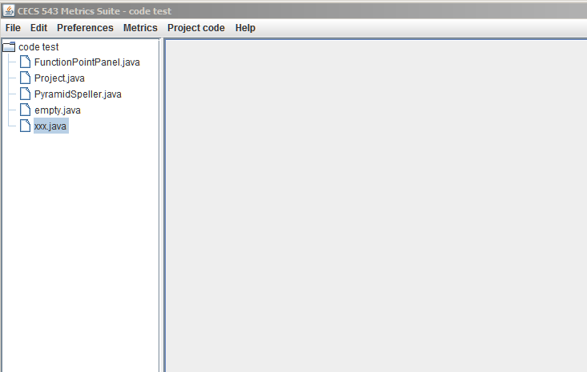
Figure 4 MS after a panels closed

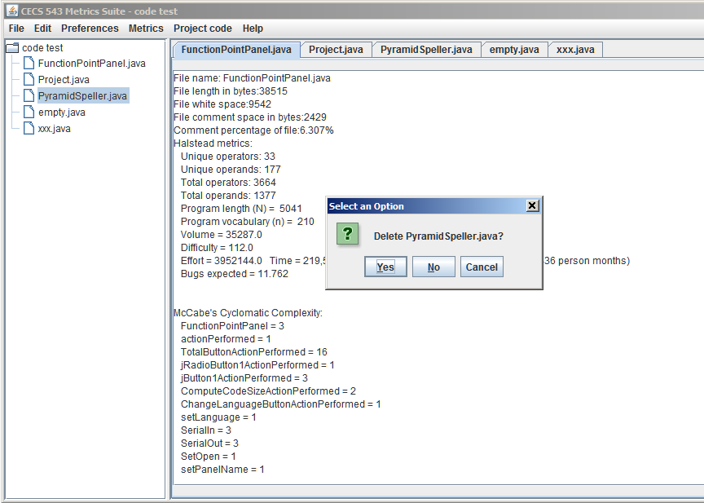
Figure 5 MS Confirm deletion message box

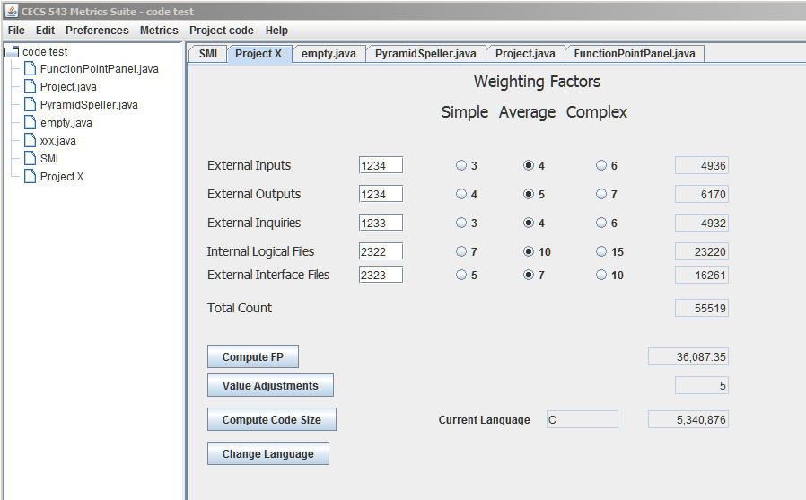
Figure 6 Code panels and named FP panel and SMI panel

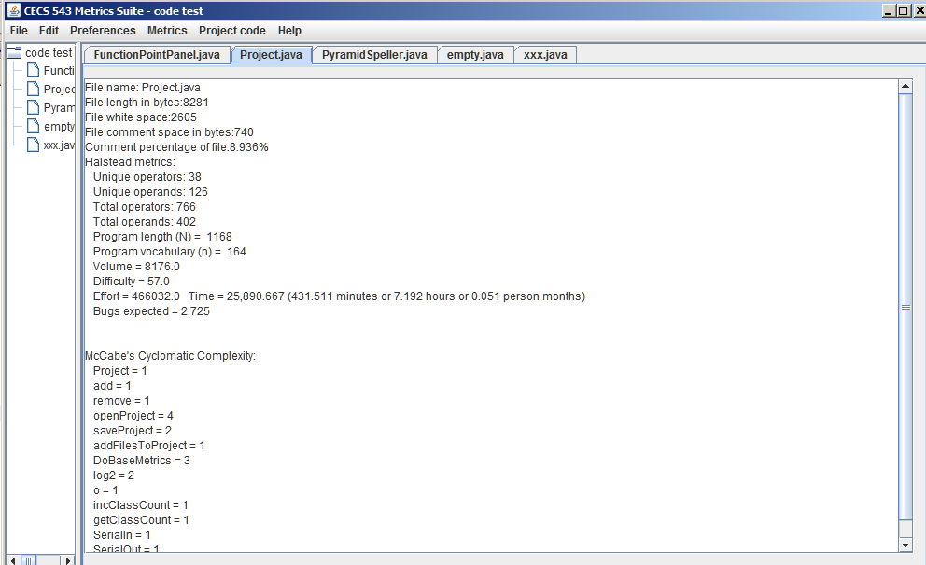
Figure 7 Note that stat panels may be larger than one screen can fit

